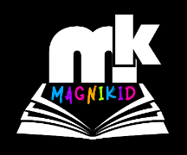
Magnikid Reading Program

We focus on: *Letter blending
*Phonetic awareness
*Sentence structure
*Reading comprehension
Who can benefit from our program?
*Kids from Grade R (ideal age) to create a firm foundation
*Any child with reading or spelling problems
*Any student or scholar who wants to improve their marks
*Students who want to improve their English / Afrikaans reading and spelling
Diagnostic testing – for free
English and Afrikaans
One on One or in a class (no more than 10)
Duration: +- 30 weeks
Where: Potchefstroom, Kock St
Contact Rachel today: 076 6983990
Costs: R400 / month or R1150 / term



